============== Docker volume =============

https://github.com/prakashk0301/product.app/tree/master/product-app

Asssignment

how to create private docker registry?push one iamge

google -open ssl

docker run -it --name myubuntu ubuntu:latest

by default storage driver is local

local storage driver:data is non persistence

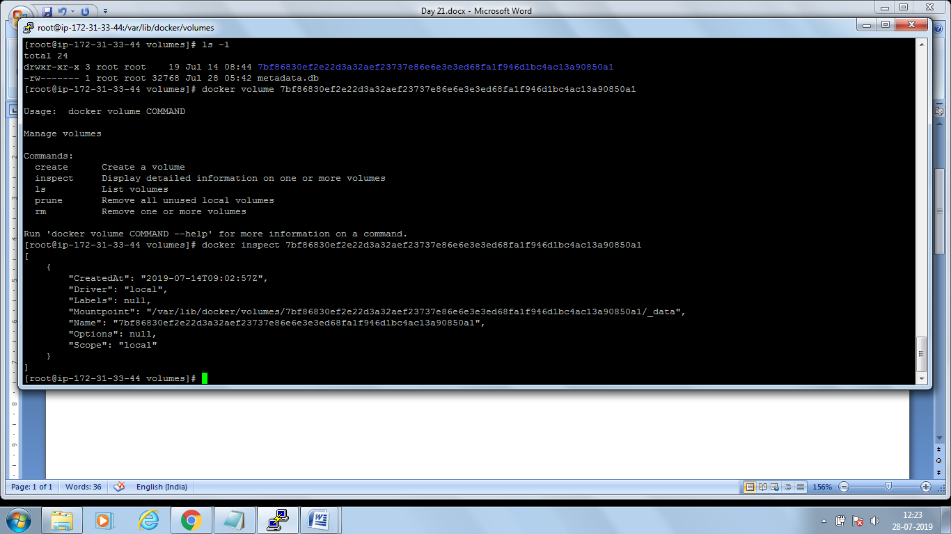

Can we connect EFS to docker containers? –Yes

docker volume create myvol

docker volume ls

docker run -itd -v myvol:/home --name myubuntu2 ubuntu:latest

docker exec -it myubuntu2 /bin/bash

cd /home

touch abc.txt

docker stop myubuntu1 myubuntu2

docker rm myubuntu1 myubuntu2

docker run -itd -v myvol:/home --name myubuntu3 ubuntu:latest

docker exec -it myubuntu3 /bin/bash

cd home

ls

Out Put:-abc.text

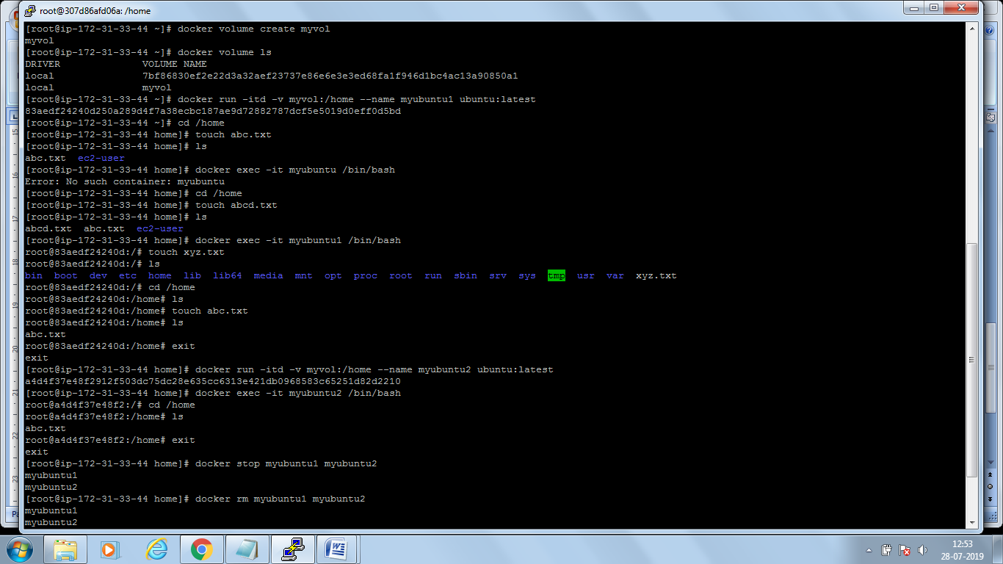

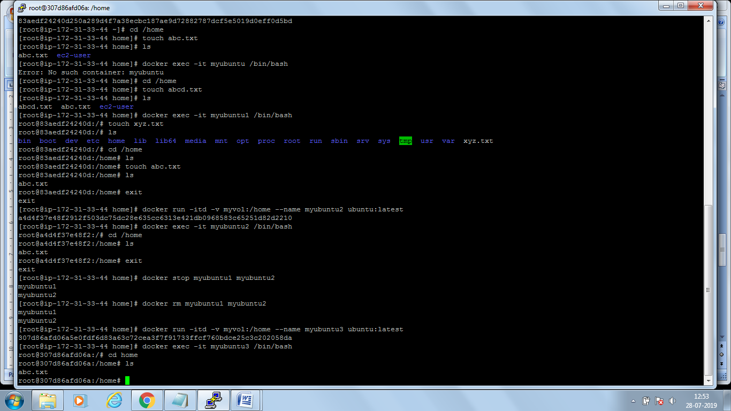

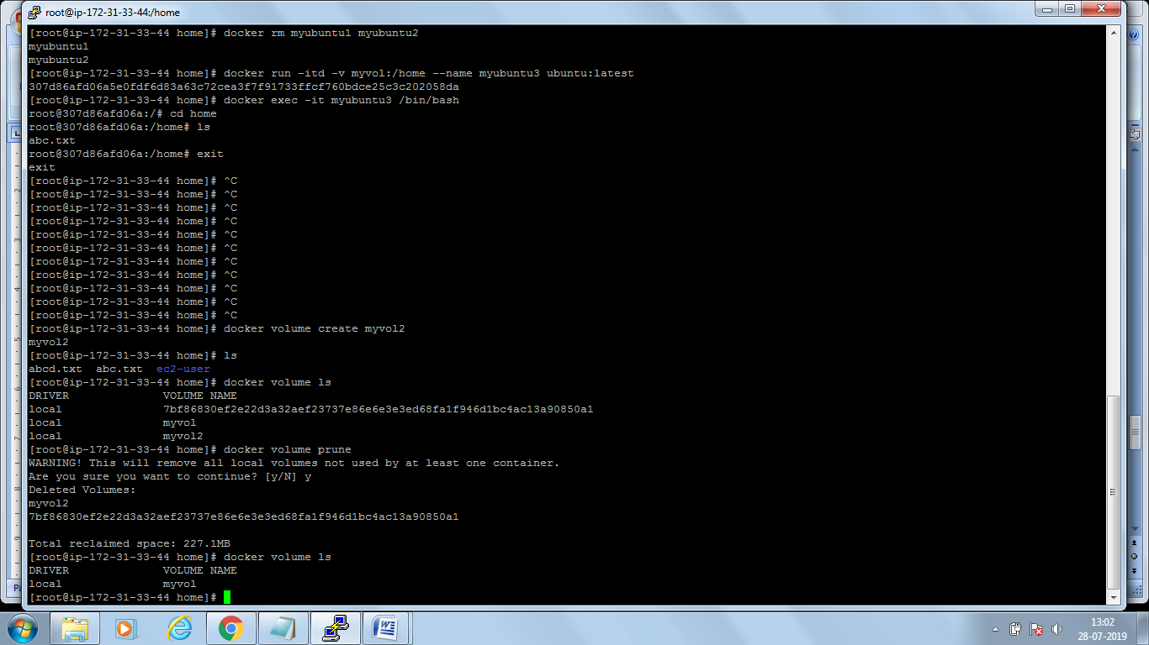

Docker volume prune – will delete unused volume

Docker volume rm <volume name> --will delete specific volume

Docker swarm is docker orchestration tool

Diff btn Docker swarm and kubernetes

Like docker swarm,kubernate,openshift,DC/OS

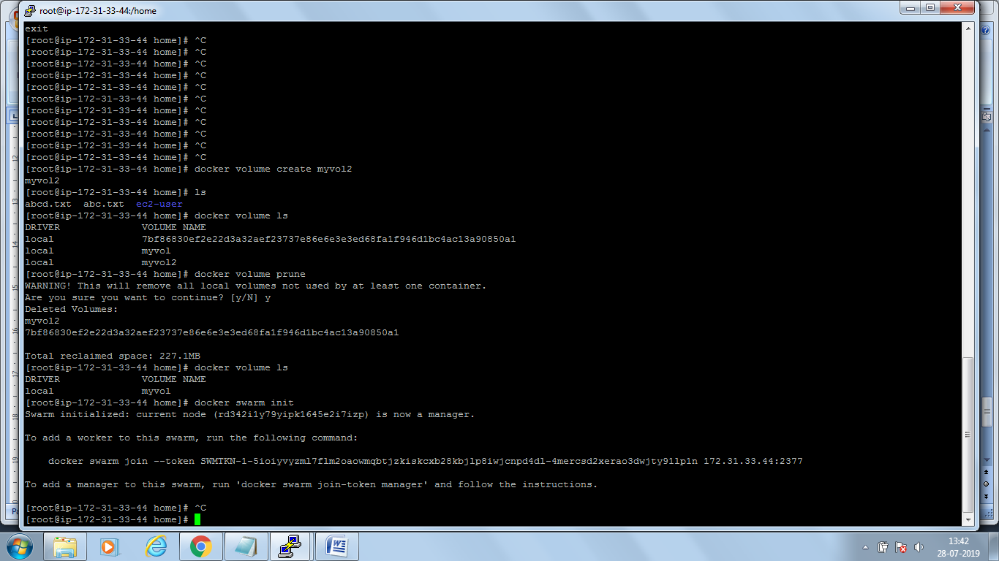

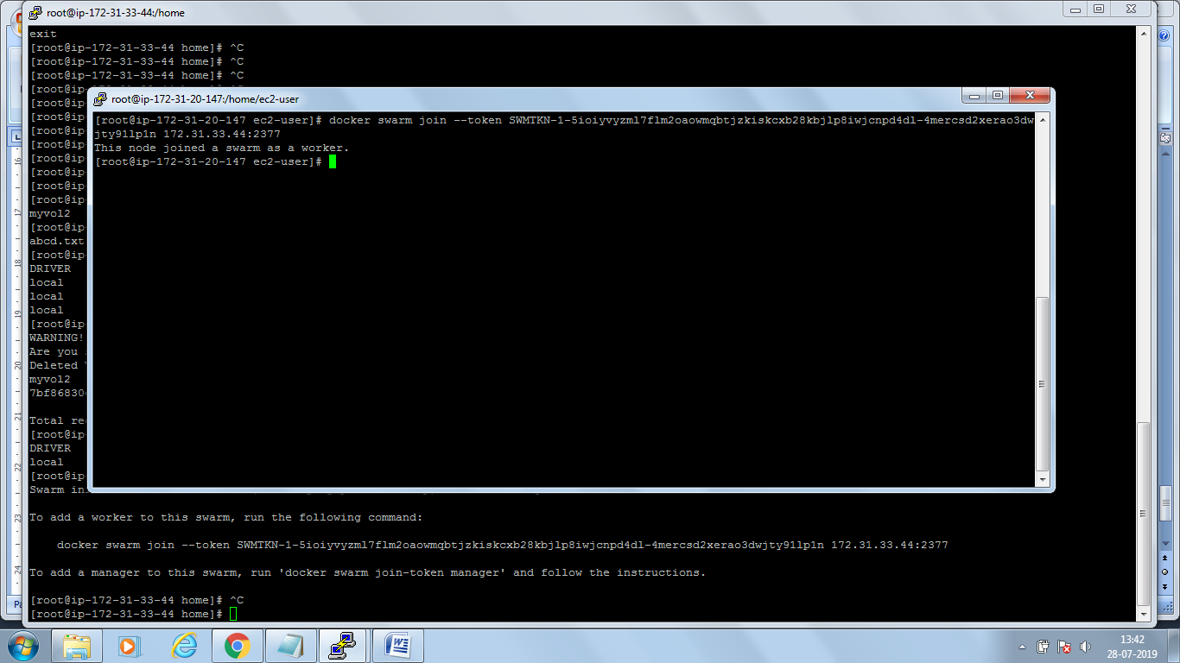

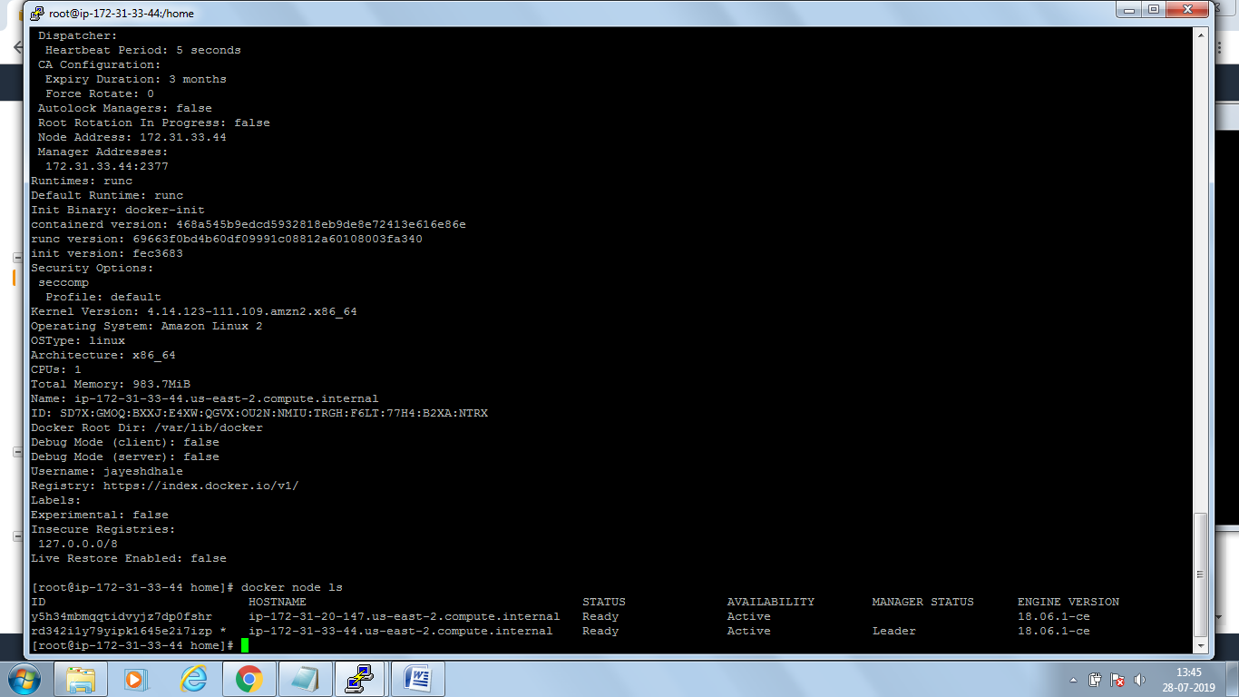

================================Day21==================

>>on master type docker swarm init and copy the command generated and paste in node VM

>>docker swarm init (generates token)

>>docker swarm join --token SWMTKN-1-66472sakxcrq3jpuae98xpczy51tz2xeeobmlf6cpg4jctow0t-2jfw62w2p68bqlbq4xnp45thk 172.31.33.171:2377 (run in host machine)

>>docker swarm run on port 2377

>>docker info (you will see nodes 2 and manager 1)

>>docker node ls (too see nodes)

>>docker network ls ( you can see now new network overlay)